**PROPERTY ANALYSIS BI DEVELOPER - ON-BOARDING TASK**

**TASK 1: Write queries to return the following:**

1. **Display a list of all property names and their property id’s for Owner Id: 1426.**

**Query:**

SELECT ownprop.OwnerId, ownprop.PropertyId, prop.Name AS PropertyName

FROM dbo.OwnerProperty ownprop

INNER JOIN dbo.Property prop ON ownprop.PropertyId = prop.Id

WHERE ownprop.OwnerId = 1426

1. **Display the current home value for each property in question a)**

**Query:**

SELECT ownprop.OwnerId, ownprop.PropertyId, prop.Name AS PropertyName

FROM dbo.OwnerProperty ownprop

INNER JOIN dbo.Property prop ON ownprop.PropertyId = prop.Id

WHERE ownprop.OwnerId = 1426

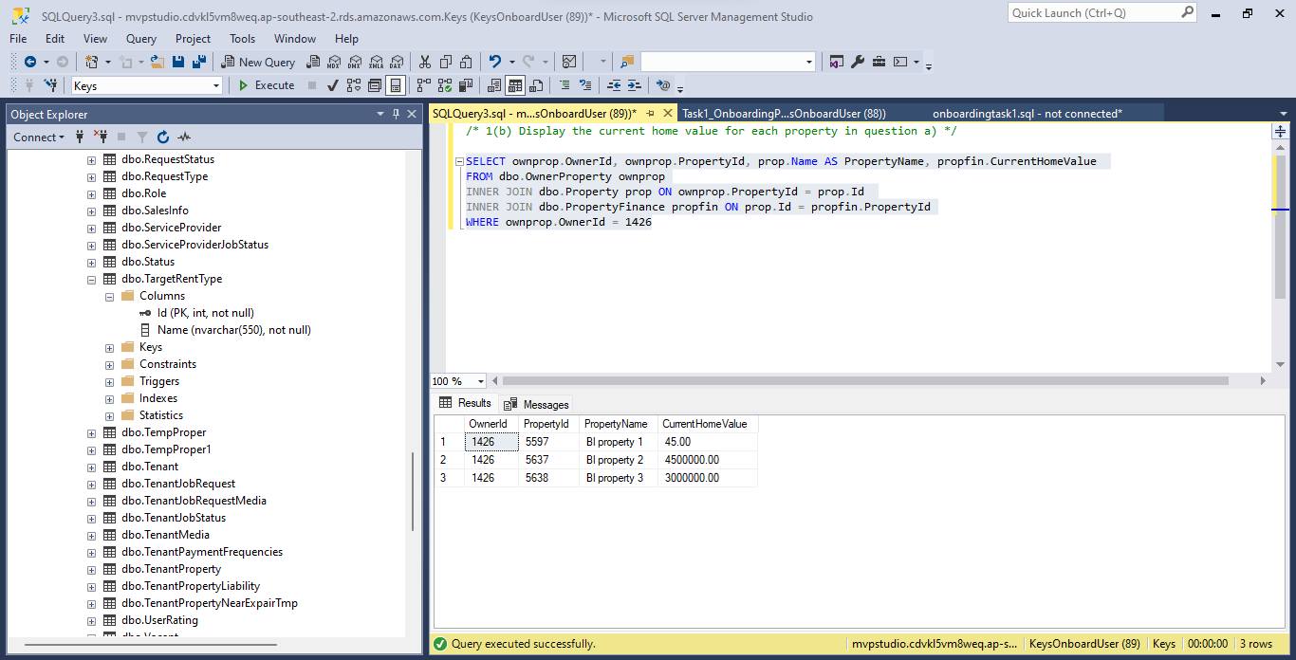

**For each property in question a), return the following:**

**c (i) Using rental payment amount, rental payment frequency, tenant start date and tenant end date to write a query that returns the sum of all payments from start date to end date.**

**Query:**

SELECT ownprop.OwnerId, ownprop.PropertyId, tenprop.TenantId, prop.Name AS PropertyName,

tenprop.PaymentAmount AS RentalPaymentAmount, tenpayfreq.Name AS RentalPaymentfrequency, tenprop.StartDate,

tenprop.EndDate ,

(CASE

WHEN tenprop.PaymentFrequencyId= '1' THEN (DATEDIFF( WEEK, tenprop.StartDate,tenprop.EndDate) *tenprop.PaymentAmount)

WHEN tenprop.PaymentFrequencyId= '2' THEN ((DATEDIFF( Week, tenprop.StartDate,tenprop.EndDate)/2) *tenprop.PaymentAmount)

WHEN tenprop.PaymentFrequencyId= '3' THEN ((DATEDIFF( Month, tenprop.StartDate,tenprop.EndDate)+1) *tenprop.PaymentAmount)

END) AS TotalRentalAmount

FROM dbo.OwnerProperty ownprop

INNER JOIN dbo.Property prop ON ownprop.PropertyId = prop.Id

INNER JOIN dbo.TenantProperty tenprop ON prop.Id = tenprop.PropertyId

INNER JOIN dbo.TenantPaymentFrequencies tenpayfreq ON tenprop.PaymentFrequencyId = Tenpayfreq.Id

WHERE ownprop.OwnerId = 1426

**c(ii) Display the yield.**

**Query:**

SELECT ownprop.OwnerId, ownprop.PropertyId, prop.Name AS PropertyName, propfin.Yield

FROM dbo.OwnerProperty ownprop

INNER JOIN dbo.Property prop ON ownprop.PropertyId = prop.Id

INNER JOIN dbo.PropertyFinance propfin ON prop.Id = propfin.PropertyId

WHERE ownprop.OwnerId = 1426

1. **Display all the jobs available**

**Query:**

Select DISTINCT j.PropertyId, j.JobDescription, j.Createdon, js.Status AS JobAvailableStatus

FROM dbo.Job j

INNER JOIN dbo.JobStatus js ON j.JobStatusId = js.Id

WHERE j.JobStatusId = 1

1. **Display all property names, current tenants first and last names and rental payments per week/ fortnight/month for the properties in question a).**

**Query:**

SELECT ownprop.PropertyId, prop.Name as PropertyName, per.FirstName as CurrentTenantsFirstName,

per.LastName as CurrentTenantsLastName, proprenpay.Amount AS RentalPaymentAmount, tarrent.Name AS RentalPaymentFrequency

FROM dbo.OwnerProperty ownprop

INNER JOIN dbo.Property prop ON ownprop.PropertyId = prop.Id

INNER JOIN dbo.TenantProperty tenprop ON prop.Id = tenprop.PropertyId

INNER JOIN dbo.Tenant tent ON tenprop.TenantId = tent.Id

INNER JOIN dbo.Person per ON tent.Id = per.Id

INNER JOIN dbo.PropertyRentalPayment AS proprenpay ON prop.Id = proprenpay.PropertyId

INNER JOIN dbo.TargetRentType AS tarrent ON proprenpay.FrequencyType = tarrent.Id

WHERE ownprop.OwnerId = 1426 AND tent.isActive = 1

**TASK 2 : Use Report Builder or Visual Studio (SSRS) to develop the following report:**

**Query:**

SELECT prop.Name AS [Property Name],ps.FirstName AS [Current Owner],

addr.Number +' '+ addr.Street + ' ,'+ addr.Suburb + ' ,' + addr.Region + ' -' + addr.PostCode AS [Property address],

CONVERT (VARCHAR(5),prop.Bedroom) + ' '+ 'Bedrooms'+ ','+' '+ CONVERT(VARCHAR(5),prop.Bathroom) +' '+ 'Bathrooms' AS [Property details],

prenp.Amount AS 'Rental payment',

prenexp.Description AS Expense,

prenexp.Amount,

prenexp.Date

FROM dbo.Property prop

INNER JOIN dbo.OwnerProperty ownprop ON prop.Id = ownprop.PropertyId

INNER JOIN dbo.PropertyRentalPayment prenp ON ownprop.PropertyId=prenp.PropertyId

INNER JOIN dbo.PropertyExpense prenexp ON ownprop.PropertyId = prenexp.PropertyId

INNER JOIN dbo.Person ps ON ps.Id = ownprop.OwnerId

INNER JOIN dbo.Address addr ON addr.AddressId = prop.AddressId

WHERE prop.Name= 'Property A' AND ps.isActive=1

